160
‘Do not hide your light under a Bushell’
The National Shrine of Our Lady

To:
The Sacristan,
RC National Shrine.
Pilgrim Bureau
Little Walsingham
Norfolk
NR22 6DB 29/08/2026

Dear Sacristan,
I enclose a copy of a letter, from Fr Alan Williams SM- dated 08/02/2010.
Following the ‘Anonymous’? donation of ‘The Chalice of The Immaculate Conception’ to The Shrine.
Also:
Chapter 2 ‘The Journey of The Chalice’ (from- theroundaboutandthebudgerigar.co.uk)
Should it be acceptable, I would also donate the Manger as described, to the Shrine, ‘Anonymously’.
May you Be Blessed.
Yours Aye,
MR

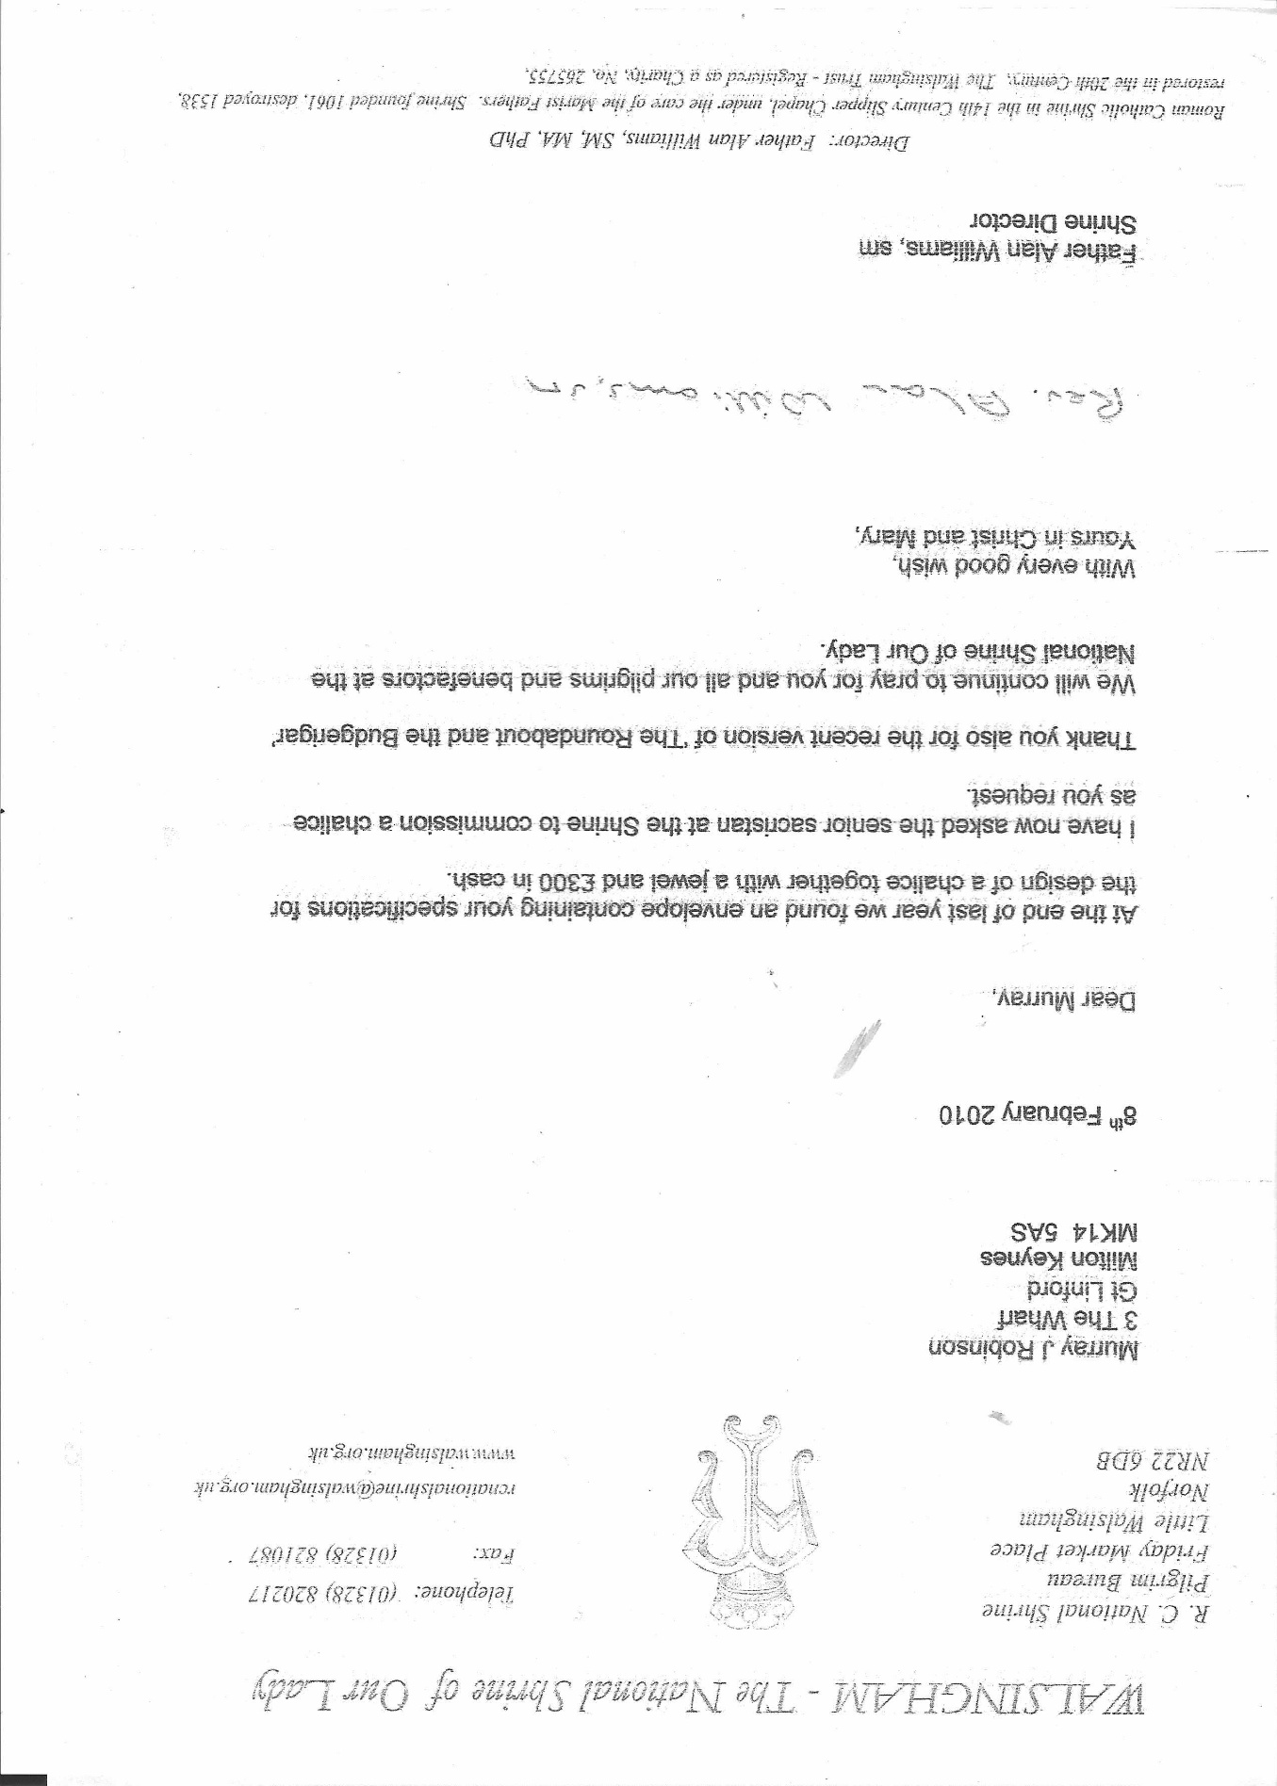

`The Journey of The Chalice

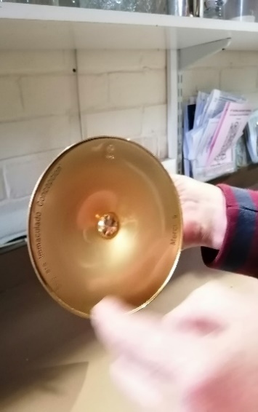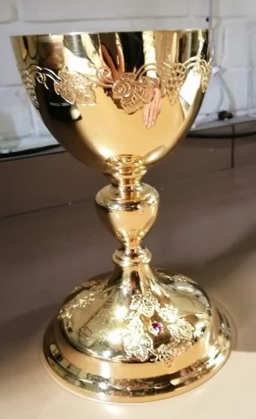

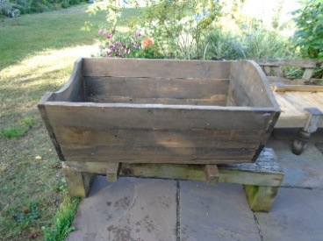

The base of the Chalice contains the words:
“ Merci a Soy Era Immaculado Concepciou”
An aspect, of this Journey has increasingly become; the encouragement of a Procession, taking this Chalice, bearing those Words of Our Lady, inscribed on this Chalice, to The Holy House of Nazareth, in Walsingham, thus, uniting our Ladys explanation of Her Nature and Disposition, as given by Her to us at Lourdes; with Our Lady of Walsingham:
“Soy Era Immaculado Concepciou”

Accompanied by a manger: to be placed before the Altar
When Empty, such a manger would remind us of those children born or unborn, damaged by another, who never had an opportunity to be lain in a manger as was Jesus Christ Our Saviour, Presented by His Parents Mary and Joseph at The Temple.
When a Small Baby, is placed in such a manger, then the child may be considered to be presented before The Holy family, akin to the manner of Jesus, being presented, in The Temple by His Parents

On the base of The Chalice is, a Small gemstone.
To remind us of, ‘Marys Tears’:

Tears such as She might shed for The Sorrow Shared between Her and Her Son as Humankind Shattered His Body and brought Him to Death on The Cross.
Tears such as a Mother might shed for a child born or unborn damaged by another.

Aspiration arising from ‘The Roundabout and the Budgerigar’

that:
The Chalice of The Immaculate Conception, found in The Slipper Chapel at Walsingham be taken in Procession for a visit, in the first place, to The Holy House of The Family of Nazareth in The Ancient- Anglican- Shrine, accompanied, by a Manger as described here.
In due course such a Chalice and Manger taken, from Walsingham to Lourdes as another is brought from Lourdes to Walsingham that we come to know Mary in Lourdes as we know Mary in Walsingham, also, Their coming together could be celebrated in Notre Dame, Paris.
I still consider Downside Abbey Benedictine,as the Crucible of my Faith. It closed recently following the Scourge of Abuse. May it be re-kindled as:
A Marian Shrine for the Sake of Children Born,or unborn damaged by another.
May other Churches also demonstrate ‘True Devotion to Mary,’ ‘Beloved Mother of Jesus Christ Our Lord and Saviour’ by Including such a Chalice and Manger in their Church.

‘Lest They Be Forgotten’

